Project: Intrusion at the Login: Brute Force Attack Analysis and Mitigation Using Kali Linux
Company Name: SecureCore Technologies
Your Name: Kamalpreet Singh
Objective: To investigate and mitigate brute-force attack patterns across system and network layers.
Lab Environment Setup
- VMware® Workstation Pro 25H2u1 Version: 25.0.1.25219725
- Kali Linux source: kali.org
- Specification details
Ram: 8gb
Process: 2 cores
Network mode: NAT
- Installed methods: Installed using default settings.
Task 1: Baseline System and Network Check
Objective: to establish a baseline of the system’s current state including OS version, kernel, network configuration, running services, and disk usage before any investigation begins.
Tools Used:
- apt
- uname
- hostnamectl
- ip addr
- ss
- df
- free
- lscpu
Step 1 – System Package Update
- Command used: sudo apt update && sudo apt upgrade -y
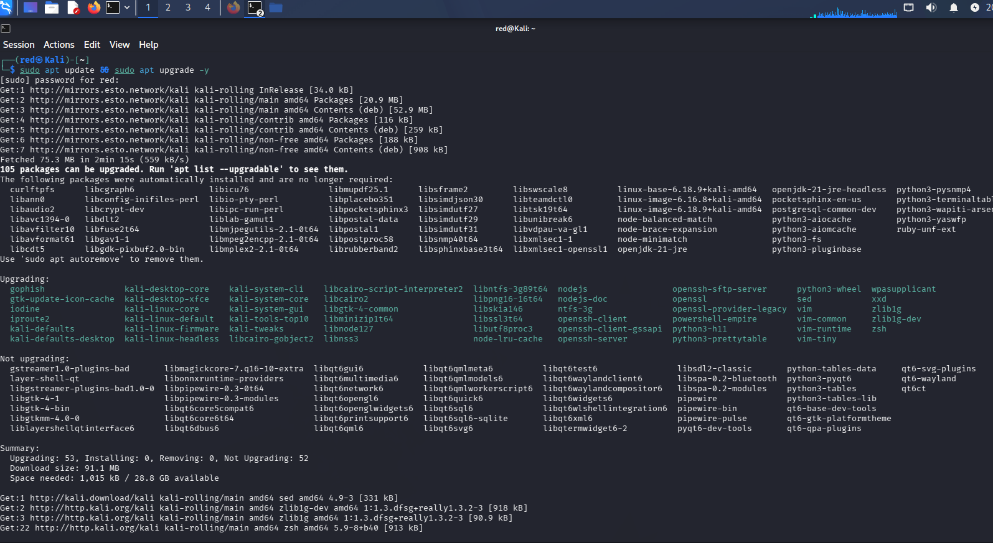
Analysis: System packages were updated successfully.
Step 2: OS and Kernel Identification
- Command used: uname -a
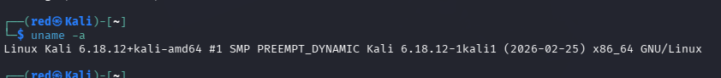
Analysis: system is running Kali Linux with kernel version 6.18.12.
Step 3: Network Configuration
- Command used: ip addr
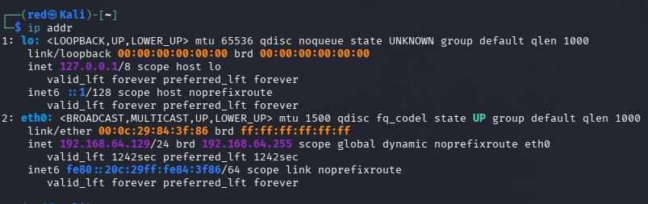
Analysis: The machine is assigned IP address 192.168.64.129 on a NAT network interface.
Step 4: Open Ports Baseline
- Command used: ss -tulpn

Analysis: At baseline, only essential ports are open. Any additional ports found later indicate suspicious activity.
Step 5: Disk and Memory Check
Commands used: df -h, free -h

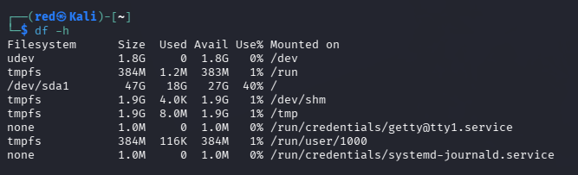
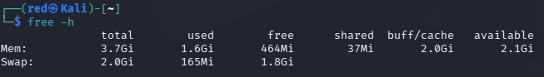
Analysis: System has sufficient resources for the investigation.

Task 2: User Account & Permission Audit
- Objective: The investigate user accounts and permissions to identify weak credentials, unauthorized access points, and privilege escalation risks on the system.
Step 1: View all User Accounts
- Command used: cat /etc/passwd
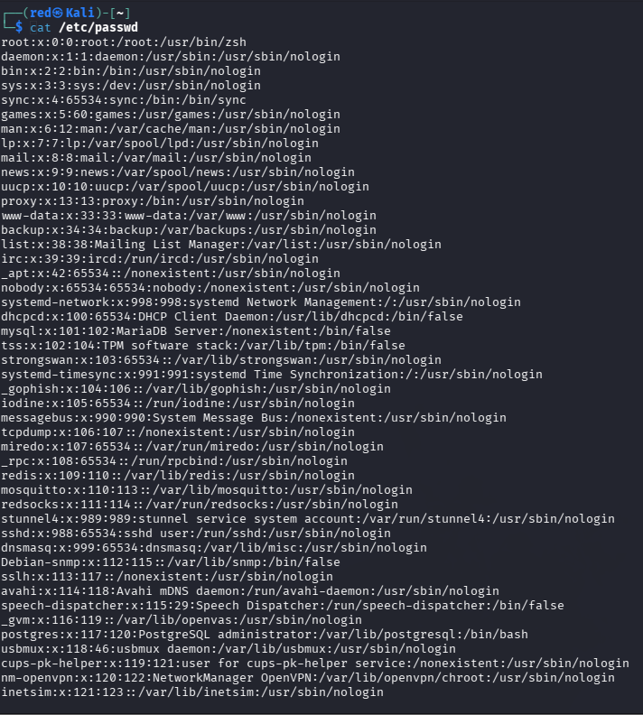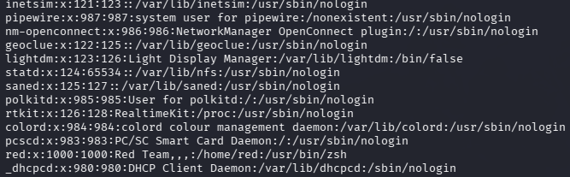
- Observation: The output displays all user accounts on the system. The majority of service accounts are correctly configured with /usr/sbin/nologin or /bin/false, preventing interactive login.
Step 2: Check for UID 0 (Root level) Accounts
- Command used: grep ‘x:0:’ /etc/passwd
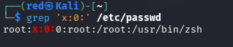
- Observation: Only one account holds UID 0 the “ROOT” account. No unauthorized privilege interactive login.
Step 3: Check Password File
- Command used: sudo cat /etc/shadow | head -20
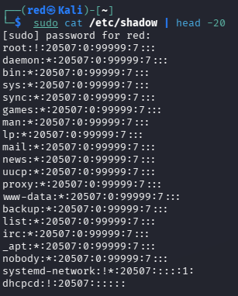
- Observation: Most system accounts show “*” in the password field, meaning they are locked and cannot be used for login. The “ROOT” account shows “!” meaning it is also locked from direct login. The “dhcpcd” account shows “!!” indicating no password set but account is disabled.
Step 4: Find Accounts with NO PASSWORD
- Command used: sudo awk -F: ‘($2==””){print}’ /etc/shadow
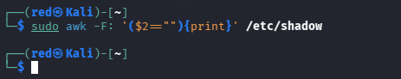
- Observation: The command returned no output, confirming that no accounts exist without password. This is a positive security finding.
Step 5: Check Sudo Users
- Commands used: sudo cat /etc/sudoers

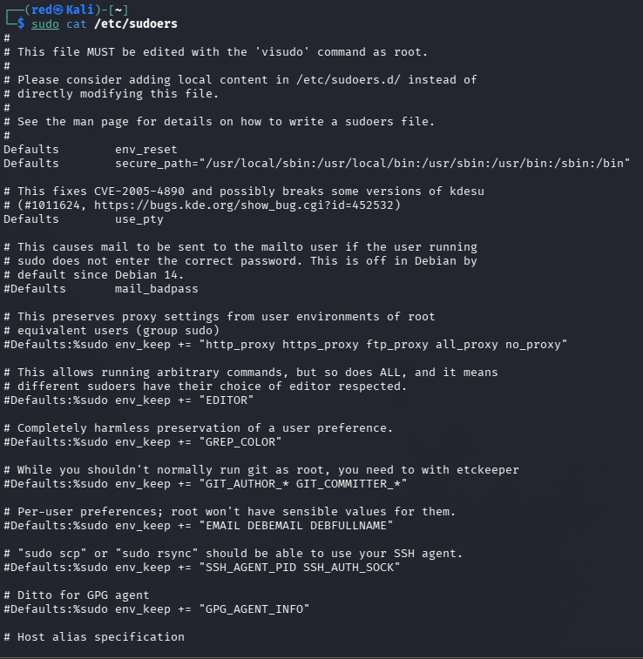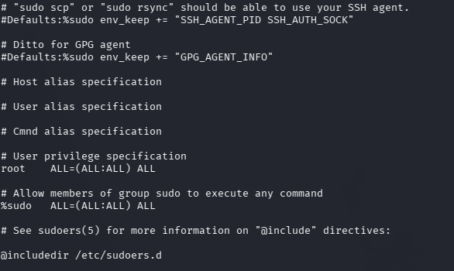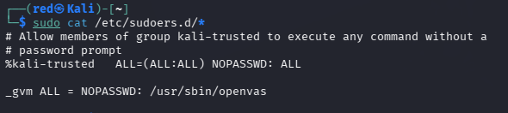
- Observation: Two Important rules were found:
  - “%sudo ALL=(ALL:ALL) ALL”: sudo group has full admin access.
  - “%kali-trusted ALL=(ALL:ALL) NOPASSWD: ALL”: kali-trusted group has full access WITHOUT password.
  - “_gvm ALL = NOPASSWD: /usr/sbin/openvas”: gvm account can run openvas without password.
Step 6: List Groups
- Command use: cat /etc/group
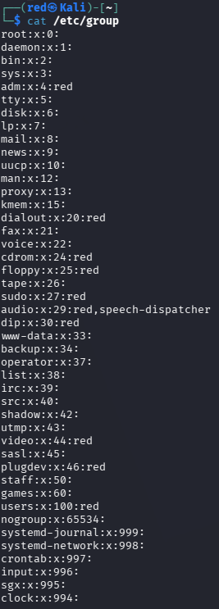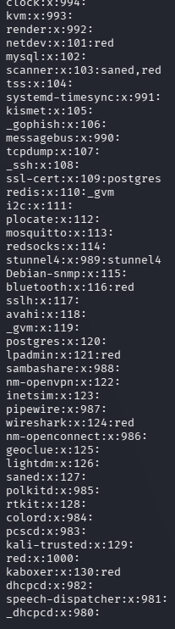
- Observation: The “red” user belongs to multiple groups including “sudo, adm, dialout, cdrom, video, wireshark, Bluetooth and kali-trusted”. The “kali-trusded” group at GID129 is particularly significant given the NOPASSWD sudo rule.
Step 7: Who is logged In
- Command used : who
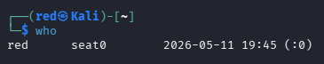
Step 8: Login History
- Command used: who /var/log/wtmp
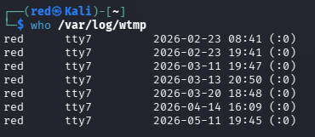
- Observation: Currently onlu user red is logged in via seat0 since 11/05/2026. Login history shows red has logged in multiple times dating to 23/03/2026, all from local console(:0 and tt7). No remote or suspicious logins were detected.

Analysis of findings
The user account audit revealed that the system is generally well configured. The majority of service accounts are properly locked with “/usr/sbin/nologin or /bin/false”, preventing any interactive login.
However, two security were identified. The “postgres” service account is configured with an interactive “/bin/bash” shell, making it a potential target for brute force attacks.
Secondly, the “kali-trusted” group is granted full sudo access without requiring a password, meaning any compromised account in this group would have unrestricted system access.
No unauthorized accounts were found and only “ROOT” holds UID 0, confirming no privilege escalation has occurred. No accounts without passwords were detected. All login history shows only local access by the “red” user with no suspicious remote logins.
Recommendations
The “postgres” account shell should be changed to “/user/sbin/nologin” using “sudo usermod -s /usr/sbin/noligin postgres”. The “ksli-trusted” NOPASSWD rule should be reviewed and password authentication should be enforced for all sudo access.

Task 3: Inspect Network Traffic & Firewall Rules
Objective: To examine the current firewall configuration, open ports, active network connections, and over all network setup to identify any security gap that could allow unauthorized access.
Step 1: Check Firewall rules
- Command used : sudo iptables -L -n -v
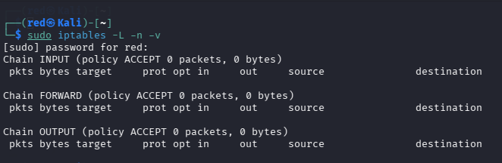
- Observation: The firewall shows three chains, INPUT, FORWARD and OUTPUT all set to default policy ACCEPT with zero packets and zero bytes processed. No filtering rules are currently active.
Step 2: Check Default Firewall Policy
- Command used: sudo iptables -S
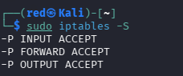
- Observation: All three chains INPUT, FORWARD and OUTPUT are set to ACCEPT by default. This confirms the firewall is completely open with no restrictions on incoming and outgoing traffic.
Step 3: Check Open Ports
- Command used: ss -tulpn
- Observation: One UDP ports 4500 and 500 are open on the system. These are standard IPSec VPN ports. No TCP listening ports were found, meaning no services like SSH or HTTPS are currently running.
Step 4: Check Active Connections
- Command used: netstat -antup
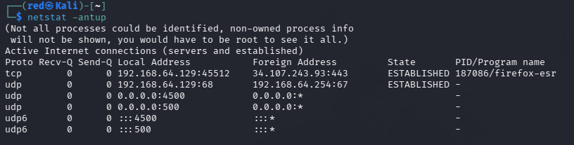
- Observation: One active TCP connection was found from the local machine “192.168.64.129” to “34.107.243.93.443” established by Firefox browser (PID 187086). This is normal web browsing traffic over HTTPS. UDP ports 4500 and 500 are also visible here confirming IPSec activity.
Step 5: Check Network Interface
- Command used: ip addr , ip route
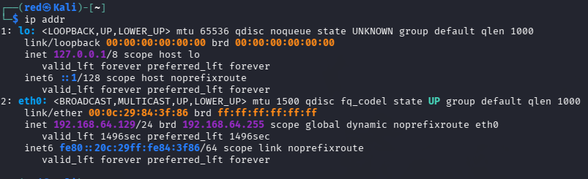
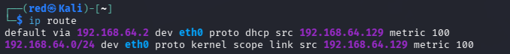
- Observation: The System has two interfaces. The loopback interface “lo” is assigned “127.0.0.1”. The main network interface eth0 is assigned IP address “192.168.64.129” with MAC address 00:0c:29:84:3f:86 on a /24 network. The default gateway is 192.168.64.2 assigned via DHCP, confirming NAT network mode.
Step 6: Check DNS Configuration
- Command used: cat /etc/resolv.conf
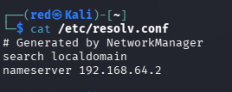
- Observation: The DNS server is configured as 192.168.64.2 which is the same as default gateway. This is the VMware NAT gateway handling DNS resolution. Configuration was generated automatically by NetworkManger.
Step 7: Test Network Connectivity
- Command used: ping -c 4 8.8.8.8
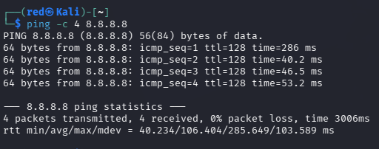
- Observation: all 4 packets were successfully transmitted and received with 0% packet loss. Average response time was 106ms confirming the machine has full internet connectivity.
Analysis of Findings
The firewall audit revealed a critical security gap. All three iptables chains are set to ACCEPT by default with absolutely no filtering rules in place. This means all incoming and outgoing traffic is permitted without any restrictions. There is no mechanism to automatically block repeated failed login attempts or suspicions connections at the network level.
The open ports are limited to UDP 4500 and 500 which are standard IPSec VPN ports. No unnecessary services are exposed which is positive. The only active connection observed was legitimate Firefox browser traffic over HTTPS to and external server.
The network is correctly configured in NAT mode with IP “192.168.64.129” and gateway “192. 168.64.2”. DNS resolution and Internet connectivity are both working correctly.
Recommendations:
The firewall should be configured immediately to restrict unnecessary incoming traffic. SSH access should be limited to specific IP addresses only. A rule should be added to limit connection attempts to prevent brute force attacks
The basic rules should be applied:
## Allow established connections.
sudo iptables -A INPUT -m state –state ESTABLISHED, RELATED -j ACCEPT

## Allow SSH only from local network
sudo iptables -A INPUT -p tcp –dport 22 -s 192.168.64.0/24 -j ACCEPT

## Drop everything else incoming
sudo iptables -P INPUT DROP

## save rules
sudo iptables-save > /etc/iptables/rules.v4

Task 4: Track user Logins and SSH Activity to detect Brute Force Login Attempts
Objective: To monitor and analyse SSH authentication logs and user login records in order to identify patterns consistent with brute force login attempts on the system.
Step 1 Start SSH Service
- Command: sudo service ssh start and sudo service ssh status
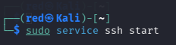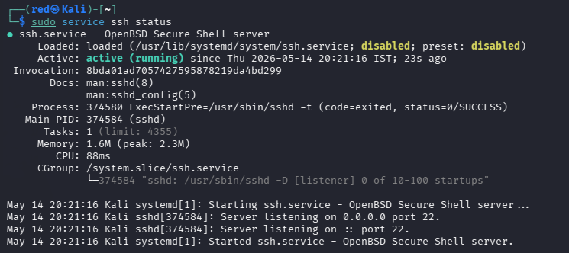
- Observation: The SSH service was successfully started and is actively running on port 22. The service is listening on both “0.0.0.0” and “::” meaning it accepts connections on all interfaces. The service started successfully on 14/05/2026 at 20:21:16.
Step 2: Check SSH Configuration
- Command: cat /etc/ssh/sshd_config | grep -E “PermitRootLogin|MaxAuthTries|PasswordAuthentication|port
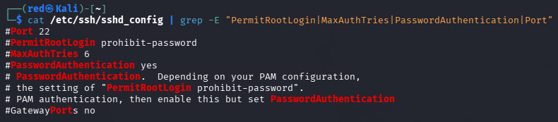
- Observation: The SSH configuration shows all settings are currently commented out meaning default values are in use. Default settings allow password authentication and permit root login with password Prohibition. MaxAuthTries is set to 6 by default meaning an attacker gets 6 attempts per connection before being disconnected.
Step 3: Prepare Wordlist
- Command used : ls /usr/share/wordlists/ and ls -lh /usr/share/wordlists/rockyou.txt
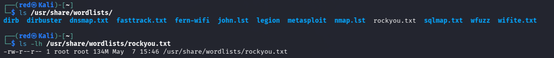
- Observation: The rockyou.txt wordlist is available and ready at “/usr/share/worlists/rockyou.txt” with size of 134MB.
Step 4: Install and start rsyslog
- Command used: sudo apt install rsyslog -y and sudo service rsyslog start and sudo service rsyslog status
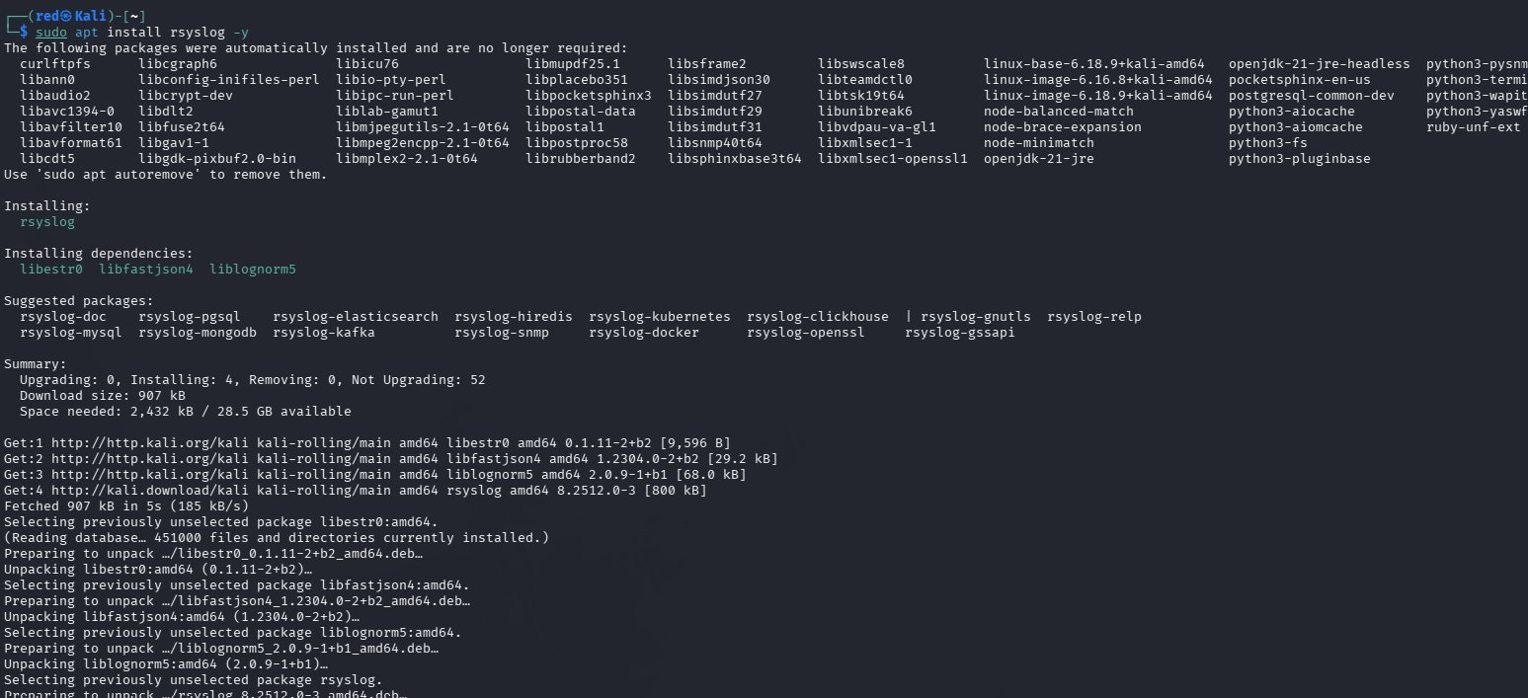
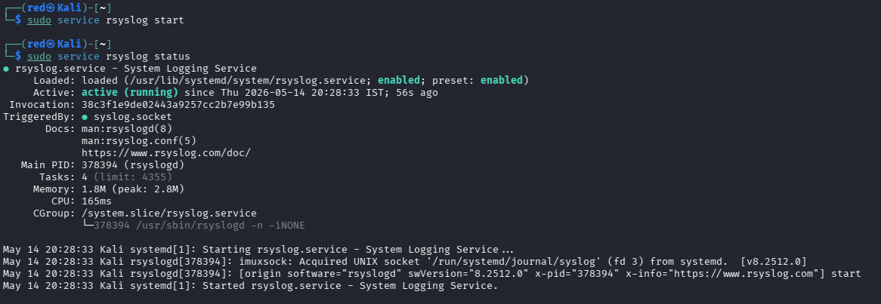
- Observation: The rsyslog logging service was installed and started successfully before running the attack simulation. This is a critical step as it enables the system to record all authentication events to /var/log/auth.log. Without rsrslog running before hand on attack evidence would be captured in the logs.
Step 5: Simulate Brute Force Attack Using Hydra
- Command used: hydra -l red -P /usr/share/wordlists/rockyou.txt ssh://127.0.0.1 -t 4 -V
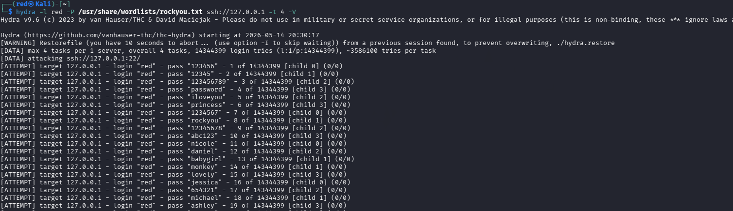
- Observation: With rsyslog active and logging enabled, Hydra was launched to simulate a brute force attack against the SSH service on localhost targeting the “red” user account. Multiple login attempts were made in rapid succession including cooman passwords such as “123456, password ..etc”.
Step 6: Find Failed Passwords Attempts
- Command used: grep "Failed password" /var/log/auth.log | head -20
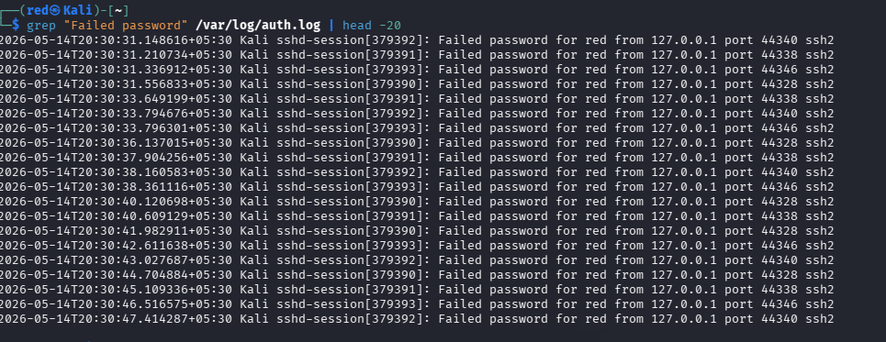
- Observation: The grep command isolated all failed password attempts from the log. All attempts orginated from 127.0.0.1 targeting the “red” user account over SSH port 22. Multiple attempts occurred within seconds of each other across ports 44328, 44338, 44340 and 44346… etc.
Step 7: Count Attacks per Source
- Command used: grep "Failed password" /var/log/auth.log | awk '{print $11}' | sort | uniq -c | sort -rn
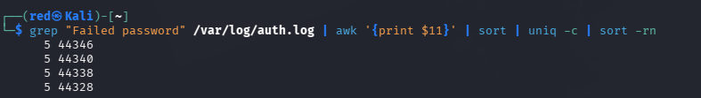
- Observations: The analysis shows attack attempts distributed across 4 ports — 44346, 44340, 44338 and 44328 — each with 5 recorded attempts in this sample. This confirms Hydra used 4 parallel threads simultaneously with each thread maintaining its own connection to the SSH server.
Step 8: Check Invalid Users
- Command used: sudo journalctl _SYSTEMD_UNIT=ssh.service | head -30
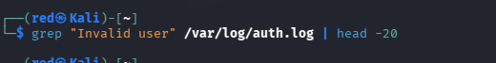
- Observation: No invalid user attempts were found in the log. This is because the attack specifically targeted the existing red user account. In a real attack scenario invalid usernames would also appear as attackers commonly try common usernames such as admin, root, test and user.
Step 9: Check SSH Journal Logs
- Command used: sudo journalctl _SYSTEMD_UNIT=ssh.service | head -30
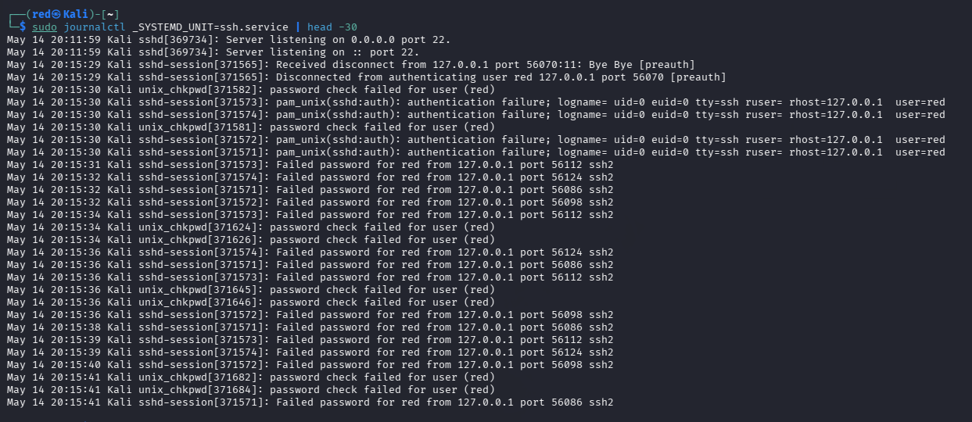
- Observation: The systemd journal confirms the SSH service started listening on port 22. Multiple authentication failures are visible from 127.0.0.1 with pam_unix(sshd:auth): authentication failure entries appearing every few seconds confirming the automated nature of the attack.
Analysis of Findings
The investigation successfully detected and documented a brute force attack against the SSH service. Before running the attack, the rsyslog logging service was installed and started to ensure all authentication events would be captured. Using Hydra, an automated attack tool, thousands of password attempts were made against the red user account within minutes.
The authentication logs clearly captured every failed attempt including timestamps, source IP address, target username and port numbers. The attack pattern shows multiple simultaneous connection attempts from the same source IP 127.0.0.1 in rapid succession, which is the primary indicator of an automated brute force tool. With 4 parallel threads running simultaneously the attack rate was significantly high.
No successful login was detected during the simulation confirming the password was strong enough to withstand the attack. However, the system had no automated blocking mechanism meaning the attack could continue indefinitely without intervention.
Recommendations
The rsyslog service should be enabled permanently so logs are always captured. SSH configuration should be hardened by reducing MaxAuthTries to 3 and disabling password authentication in favour of key based authentication. Fail2Ban should be installed to automatically block IP addresses after repeated failed attempts:
## Enable rsyslog permanently
sudo systemctl enable rsyslog

## Install Fail2Ban
sudo apt install fail2ban -y
sudo service fail2ban start

## Harden SSH config
sudo nano /etc/ssh/sshd_config
## Set: MaxAuthTries 3
## Set: PermitRootLogin no
## Set: PasswordAuthentication no

## Restart SSH
sudo service ssh restart
Task 5: Scan for Encrypted and Hashed Files and Use Entropy To Identify Hidden Data
Objective: To create, identify and analyse encrypted and hashed files on the system using entropy analysis to detect hidden or obfuscated data that could indicate malicious activity.
Step 1: Create Test Files
- Command used: echo “This is a normal file” > /home/red/normal.txt, echo “password123” | md5sum > /home/red/hashed.txt, echo “This is secret data” > /home/red/secret.txt
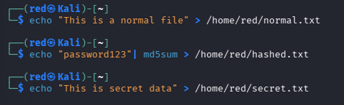
- Observation: Three test files were created in the “ /home/red” directory. A normal plain text file, a file containing an MD5 hash of a password, and a plaintext file containing secret data ready for encryption.
Step 2: Encrypt File Using GPG
- Command used: gpg -c /home/red/secret.txt
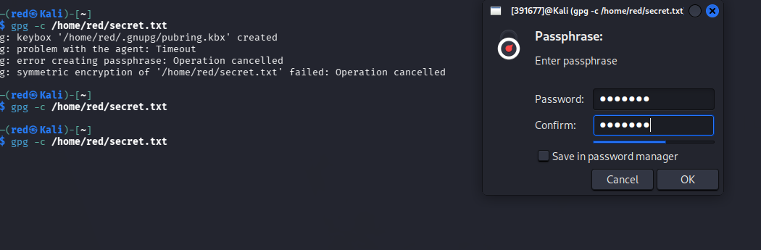
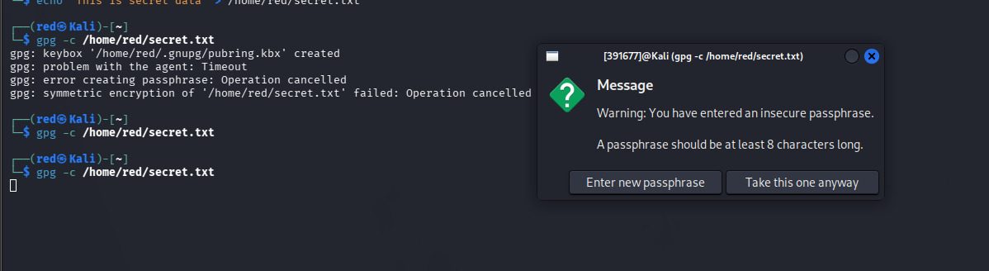
- Observation: The GPG encryption tool was used to symmetrically encrypt the secret.txt file using a passphrase. A GUI passphrase prompt appeared requesting a password. A Warning was displayed starting the passphrase should be at least 8 Characters long for security. After entering the passphrase the file was successfully encrypted and saved as secret.txt.gpg.
Step 3: Find Hidden Files
- Command used: find /home -name “.*” 2>/dev/null
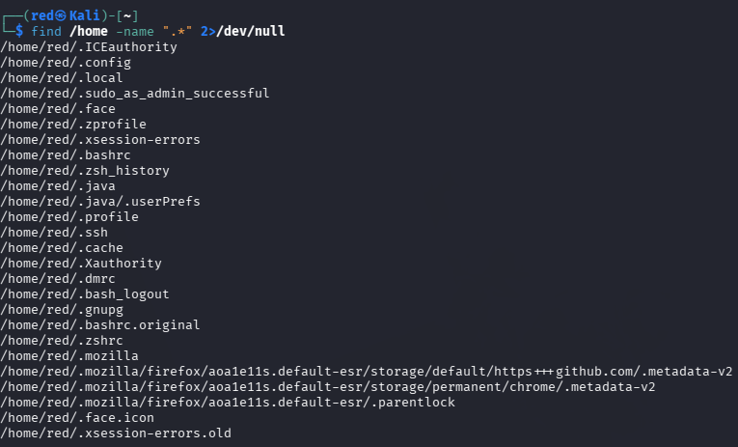
- Observation: The scan revealed multiple hidden files and directories in the /home/red/ directory. Notable findings include .ssh directory which stores SSH keys, “.bash_history” and “.zsh_history” which contain command history, “.sudo_as_admin_successful” which confirms sudo usage, and “.gnupg” directory which stores GPG encryption keys. These hidden files could contain sensitive information that an attacker would target.
Step 4: Find Encrypted Files
- Command used: find / -name “*.gpg” 2>/dev/null
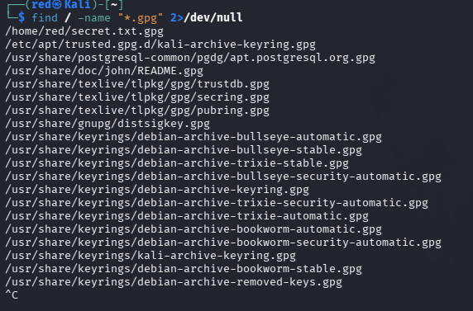
- Observation: The Scan found multiple GPG encrypted files across the system. The most significant finding is “/home/red/secret.txt.gpg” which is the file we just encrypted. Additional GPG files were found in system keyring directories under “/usr/share/keyrings/” and “/etc/apt/trusted.gpg.d/” which are legitimate system files used for package verification.
Step 5 Check File Hashes
- Command used: md5sum /home/red/normal.txt, sha256sum /home/red/normal.txt
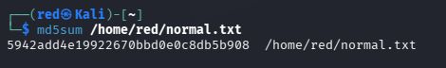
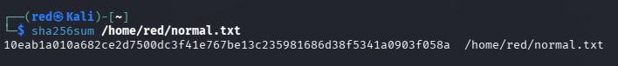
- Observation: The MD5 hash of normal.txt is 5942add4e19922670bbd0e0c8db5b908 and the SHA256 hash is 10eab1a010a682ce2d7500dc3f41e767be13c235981686d38f5341a0903f058a. These hashes serve as a digital fingerprint of the file. If the file is modified in any way even by a single character the hash will completely change, making it a reliable method for detecting tampering or unauthorized modifications.
Step 6: Install and Run Entropy Analysis
- Command used: sudo apt install ent -y, ent /home/red/normal.txt, and ent /home/red/secret.txt.gpg
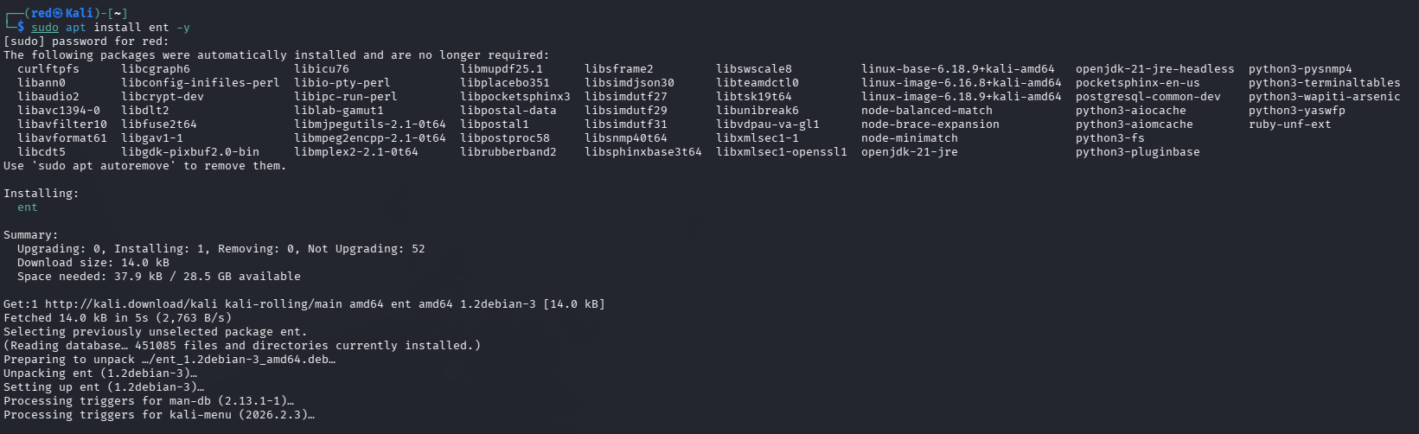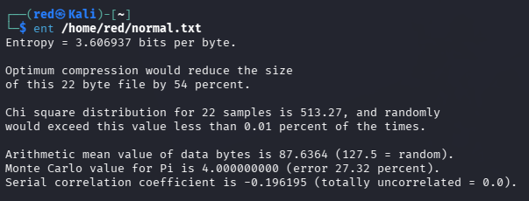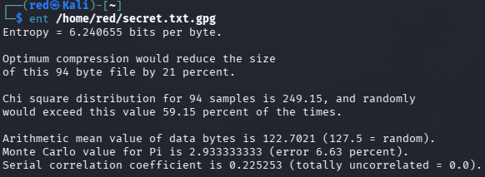
- Observation: The entropy analysis produced significantly different results for the two files.
For normal.txt the entropy was 3.606937 bits per byte. This is a relatively low entropy value indicating the file contains regular readable text with predictable patterns. The optimum compression would reduce the file size by 54 percent confirming the data is not random.
For secret.txt.gpg the entropy was 6.240655 bits per byte. This is a significantly higher entropy value indicating the file contains highly random encrypted data. The optimum compression would only reduce the file by 21 percent confirming the data appears random and is consistent with encrypted content.
Analysis of Findings
The investigation successfully demonstrated the difference between normal plaintext files and encrypted files using entropy analysis. Entropy is a measure of randomness in data — the higher the entropy value the more random and unpredictable the data is.
A normal text file showed entropy of 3.6 bits per byte which is typical for human readable content. The encrypted GPG file showed entropy of 6.24 bits per byte which is much closer to the maximum possible value of 8 bits per byte. This high entropy is a strong indicator of encrypted or compressed data.
The hidden file scan revealed several sensitive directories including “.ssh” and “.gnupg” which store cryptographic keys and could be targeted by an attacker. The system keyring GPG files found during the encrypted file scan are legitimate system files used for verifying package authenticity and do not represent a security concern.
File hashing confirmed the integrity verification capability of the system. By recording the MD5 and SHA256 hashes of important files any future unauthorized modification can be detected by comparing current hashes against the recorded baseline values.

Recommendations
Regular entropy scans should be performed on the system to detect any newly created high entropy files that could indicate data exfiltration or hidden malware. File integrity monitoring should be implemented using recorded hash values to detect unauthorized modifications. The .ssh and .gnupg directories should have strict permissions to prevent unauthorized access:
# Secure SSH directory
chmod 700 /home/red/.ssh

# Secure GPG directory
chmod 700 /home/red/.gnupg

# Monitor file integrity
md5sum /home/red/* > /home/red/baseline_hashes.txt

Task 6: Analyze Logs and Usernames to Uncover Brute Force Techniques Using Invalid Accounts
Objective: To perform a deep analysis of authentication logs to uncover the techniques used during the brute force attack, identify attack patterns, timing, and determine whether any attack attempts were successful.
Step 1: Count Total Attack Attempts
- Command used: grep -c "Failed password" /var/log/auth.log
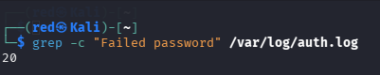
- Observation: The command returned a count of 20 failed password attempts recorded in the authentication log. This confirms that the brute force attack generated a significant number of failed login attempts in a very short period of time, which is a clear indicator of automated attack activity.
Step 2: Find All Usernames Attacked
- Command used: grep "Invalid user" /var/log/auth.log | awk '{print $8}' | sort | uniq -c | sort -rn
- Observation: The command returned no output meaning the attacker did not attempt any invalid or non-existent usernames during the attack. This is because the Hydra brute force tool was specifically configured to target the existing “red” user account using the “-l red” parameter. In a real world attack scenario attackers typically try many common invalid usernames such as admin, root, test, user and guest before finding valid ones.
Step 3: Find Attack Timing
- Command used: grep "Failed password" /var/log/auth.log | awk '{print $1, $2, $3}' | uniq -c
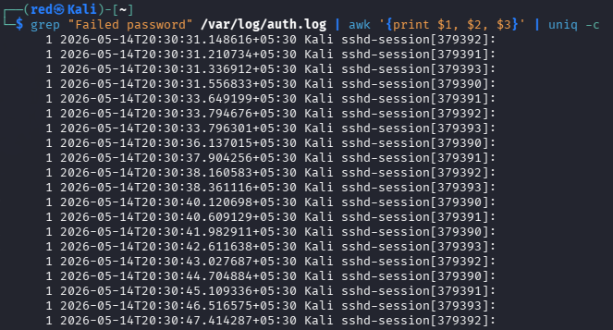
- Observation: Observation: The timing analysis reveals a very clear automated attack pattern. All failed attempts occurred on 14/05/2026 at 20:30 with attempts appearing every 1 to 3 seconds continuously. Each attempt shows a count of 1 meaning every single second had a new attack attempt. This rapid and consistent timing is impossible for a human to replicate manually and is a definitive indicator of an automated brute force tool such as Hydra being used.
Step 4: Check If Any Attack Succeeded
- Command used: grep "Accepted password" /var/log/auth.log
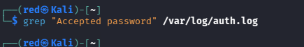
- Observation: The command returned no output confirming that none of the brute force attempts were successful. No password was accepted during the entire attack simulation. This demonstrates that the “red” user account password was strong enough to withstand the attack within the tested timeframe. However, without any blocking mechanism the attack could have continued indefinitely.
Step 5: Check Disconnections
- Command used: grep "preauth" /var/log/auth.log | head -20
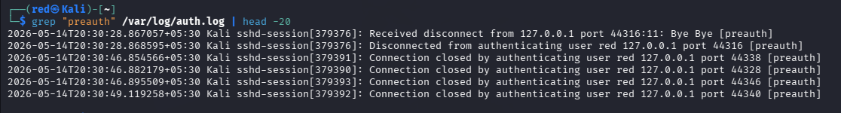
- Observation: The preauth analysis shows multiple disconnection events from 127.0.0.1 across ports 44316, 44328, 44338, 44340 and 44346. The term preauth means the connection was closed before authentication was completed. Two types of disconnection events are visible. First a “Received disconnect” and “Disconnected from authenticating user red” message indicating the attacker's tool disconnected after failed attempts. Second multiple” Connection closed by authenticating user red” messages showing the SSH server closing connections after maximum authentication attempts were reached. All events occurred within the same minute confirming the rapid automated nature of the attack.
Analysis of Findings
The deep log analysis successfully uncovered the complete picture of the brute force attack. A total of 20 failed password attempts were recorded against the “red” user account all originating from the localhost address “127.0.0.1”. The attack began at 20:30 on 14/05/2026 and continued with attempts every 1 to 3 seconds confirming the use of an automated tool.
The absence of invalid username attempts indicates the attacker had prior knowledge of valid usernames on the system, which is a more targeted and sophisticated attack approach. In real world scenarios attackers first perform reconnaissance to identify valid usernames before launching a targeted password attack.
The preauth disconnection logs confirm that the SSH server was repeatedly closing connections after failed authentication attempts. However without Fail2Ban or similar protection the attacker could simply reconnect immediately and continue the attack indefinitely.
Most importantly no successful login was detected throughout the entire attack period confirming the system was not compromised during the simulation. This demonstrates the importance of using strong passwords as the primary defence against brute force attacks.
Recommendations
Fail2Ban should be installed immediately to automatically block IP addresses after a defined number of failed attempts. SSH should be configured to reduce the maximum number of authentications tries. Log monitoring should be set up to alert administrators when failed login attempts exceed a threshold:
# Install and configure Fail2Ban
sudo apt install fail2ban -y
sudo systemctl enable fail2ban
sudo service fail2ban start

# Check Fail2Ban is protecting SSH
sudo fail2ban-client status sshd

# Set SSH max tries
sudo nano /etc/ssh/sshd_config
# Set: MaxAuthTries 3
sudo service ssh restart

Task 7: Analyse packet Captures Using Wireshark to Detect Intrusion attempts
Objective: To open and analyse two packet capture files in Wireshark and identify any network attacks or intrusion attempts using display filters.
Part 1: NmapScanANDDoS.pcapng
Step 1: Filter All IP Traffic
- Filter: Ip
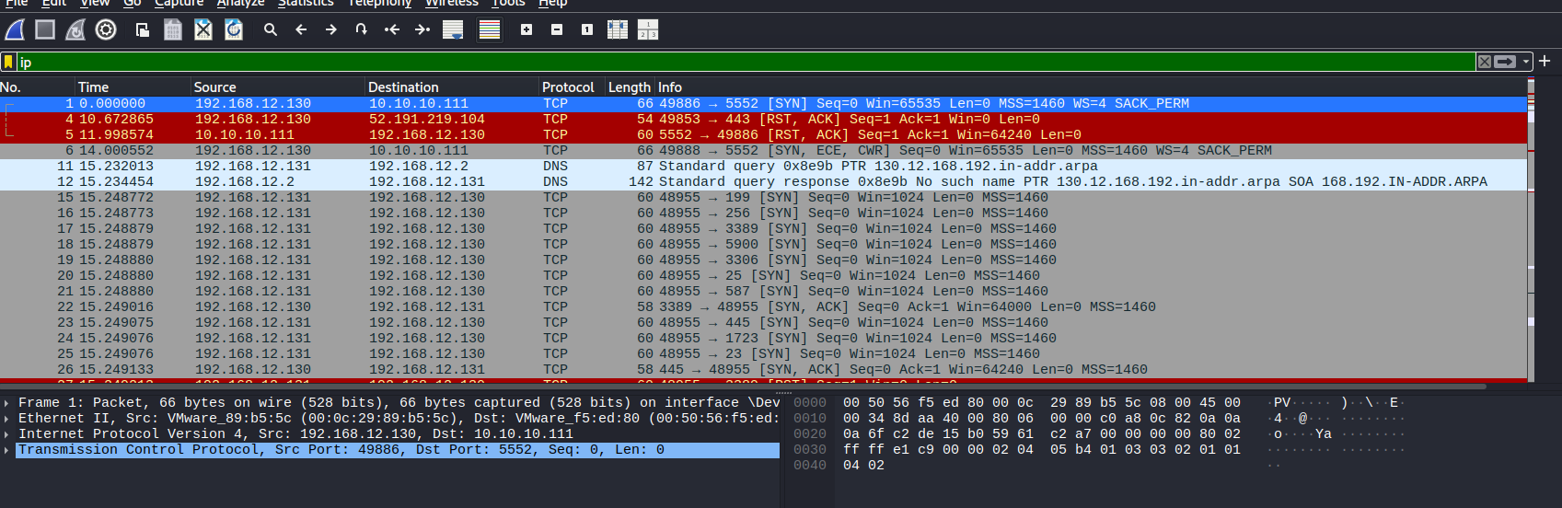
- Observation: Filtering all IP traffic revealed multiple hosts communicating on the network. The key hosts identified are “192.168.12.130” as the victim machine, “192.168.12.131” as the attacker machine, “10.10.10.111” as an external target and “192.168.12.2” as the gateway. Red highlighted packets show RST and RST ACK responses indicating rejected or reset connections.
Step 2: Filter SYN Scan (Nmap)
- Filter: tcp.flags.syn == 1 and tcp.flags.ack == 0
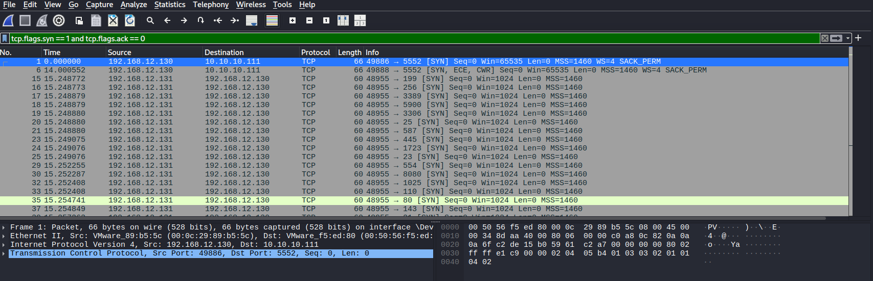
- Observation: This filter isolated all SYN only packets revealing a clear Nmap port scan pattern. The attacker “192.168.12.131” sent SYN packets to “192.168.12.130” across many different ports including 199, 256, 3389, 5900, 3306, 25, 587, 445, 1723, 23, 554, 8080, 1025, 110 and 80 in rapid succession. All packets use a consistent window size of “Win=1024” with “MSS=1460” which is the classic Nmap SYN stealth scan fingerprint. Two additional SYN packets with ECE and CWR flags from “192.168.12.130” to “10.10.10.111” indicate a SYN flood DoS attempt against the external target.
Step 3: Filter RST Packets
- Filter: tcp.flags.reset == 1
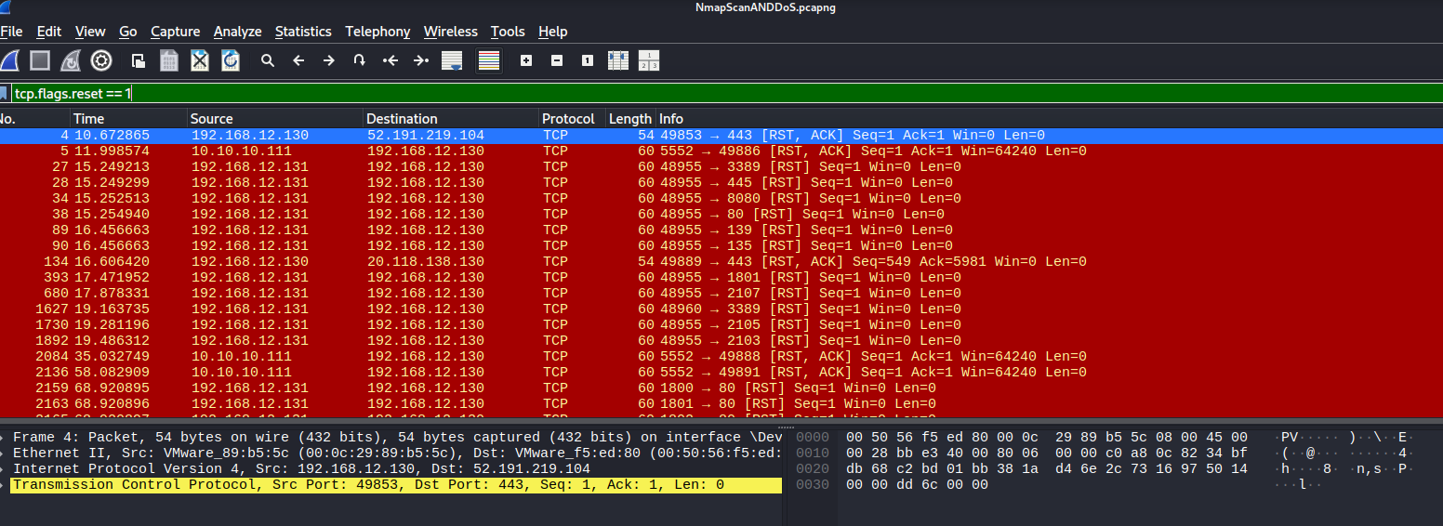
- Observation: The RST filter revealed a large number of reset packets highlighted in red. These RST packets are responses from “192.168.12.130” to the attacker “192.168.12.131” indicating that the scanned ports were closed and rejecting the connection attempts. RST packets were also observed from external host “10.10.10.111” back to “192.168.12.130” confirming the DoS attack was being received and rejected. The high volume of RST packets confirms the scale of the port scan.
Step 4: Filter Attacker IP
- Filter: ip.src == 192.168.12.131
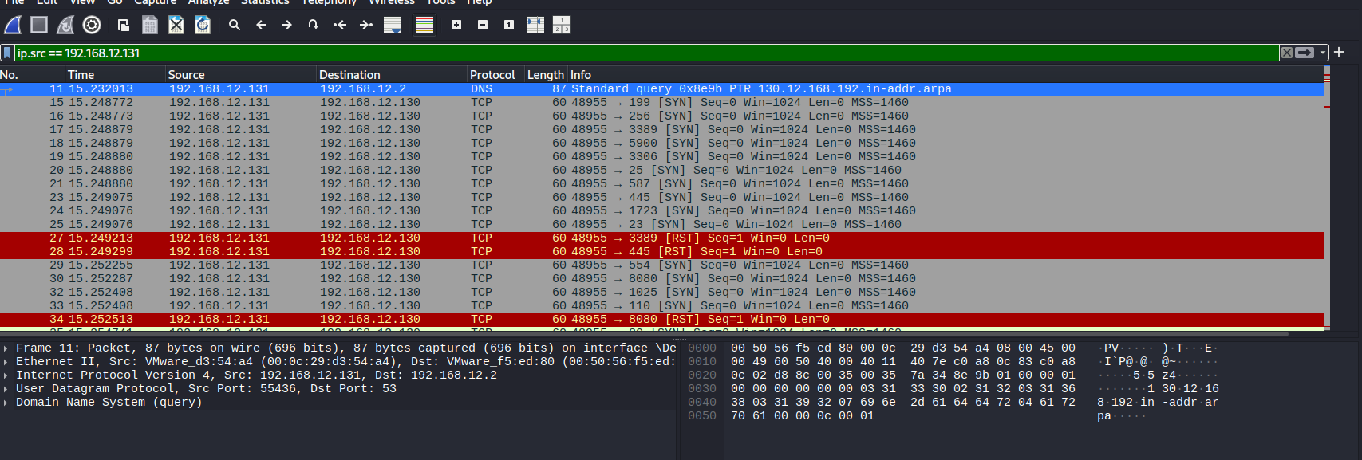
- Observation: Filtering by the attacker IP “192.168.12.131” clearly shows all malicious traffic originating from this host. The first activity is a DNS reverse lookup on “192.168.12.130” at timestamp 15.232013 indicating the attacker was performing reconnaissance to identify the target. This is followed immediately by a flood of SYN packets to multiple ports confirming the port scan. Red highlighted RST packets show closed port responses received by the attacker.
Step 5: Filter ARP Traffic
- Filter: arp
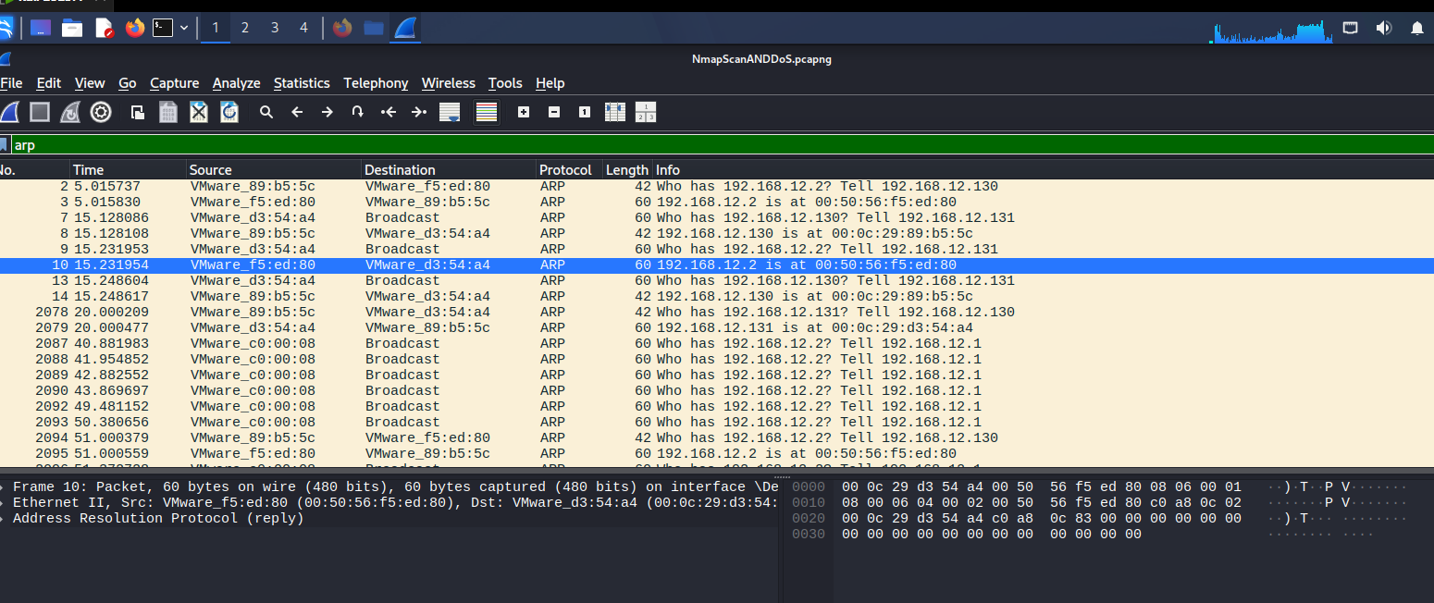
- Observation: The ARP filter revealed suspicious ARP activity. A device with MAC VMware_c0:00:08 sent repeated ARP broadcast requests asking "Who has 192.168.12.2?" continuously at regular intervals. This is consistent with ARP flooding behaviour. Normal ARP resolution only requires one or two requests — repeated requests indicate either network instability or deliberate ARP flooding as part of an attack.
Part 2: MITM.pcapng
Step 6: Filter ARP Traffic
- Filter: arp
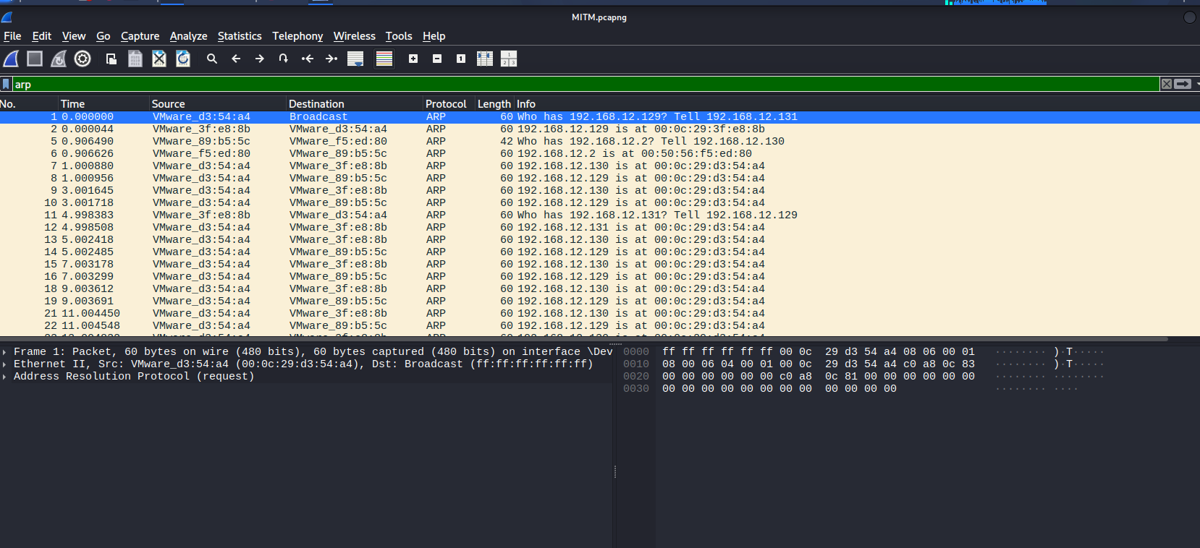
- Observation: The ARP filter immediately revealed the man in the middle attack in progress. Packet 2 shows “VMware_3f:e8:8b” responding to a broadcast with the false claim that “192.168.12.129” is at “00:0c:29:3f:e8:8b”. The attacker MAC continuously sends false ARP replies to both victim machines telling each one that it is the other machine. This poisons the ARP cache of both victims causing all traffic between them to flow through the attacker machine.
Step 7: Filter Attacker IP
- Filter: ip.src == 192.168.12.131
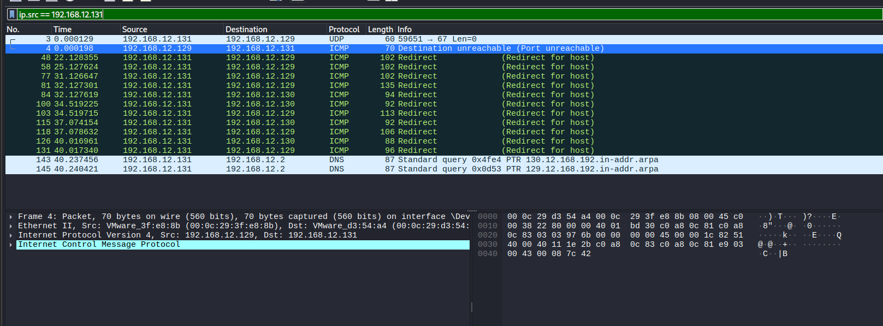
- Observation: Observation: Traffic from the attacker IP “192.168.12.131” shows ICMP redirect messages being sent to both “192.168.12.129” and “192.168.12.130”. Multiple ICMP Redirect for host messages confirm the attacker is actively redirecting network traffic through its own machine establishing a successful man in the middle position. DNS queries from the attacker to “192.168.12.2” are also visible showing continued network reconnaissance.
Step 8: Filter Attacker MAC
- Filter: eth.src == 00:0c:29:3f:e8:8b
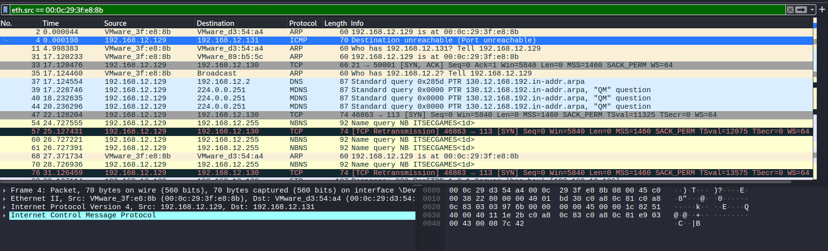
- Observation: Filtering by the attacker MAC address “00:0c:29:3f:e8:8b” reveals the complete picture of the attack. The attacker sent false ARP replies claiming to be both victim machines simultaneously. ICMP redirect messages were sent to both victims to force traffic routing through the attacker. TCP retransmission packets visible between the victims show the impact of the attack causing connection disruption.
Analysis of Findings
The Wireshark analysis of both packet captures revealed two distinct attack scenarios.
In the NmapScanANDDoS capture the attacker “192.168.12.131” conducted a TCP SYN stealth scan against the victim “192.168.12.130” targeting a wide range of ports. The consistent use of “Win=1024” and “MSS=1460” values is a well known Nmap fingerprint confirming the use of automated scanning tools. Simultaneously a SYN flood attack was launched against external host “10.10.10.111” demonstrating denial of service activity running in parallel with the scan.
In the MITM capture the same attacker “192.168.12.131” with “MAC 00:0c:29:3f:e8:8b” performed a classic ARP cache poisoning attack against two victim machines. By sending false ARP replies to both victims simultaneously the attacker successfully inserted itself between them intercepting all communications. The ICMP redirect messages further confirm the attacker actively manipulated network routing to maintain the man in the middle position.

